PicoCTF 2025

Fantasy CTF
Play through the story
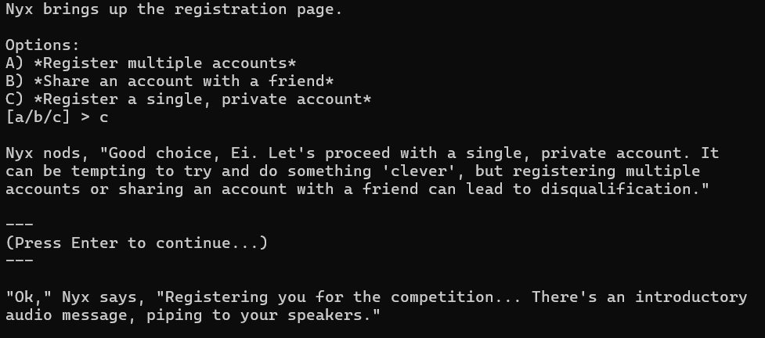
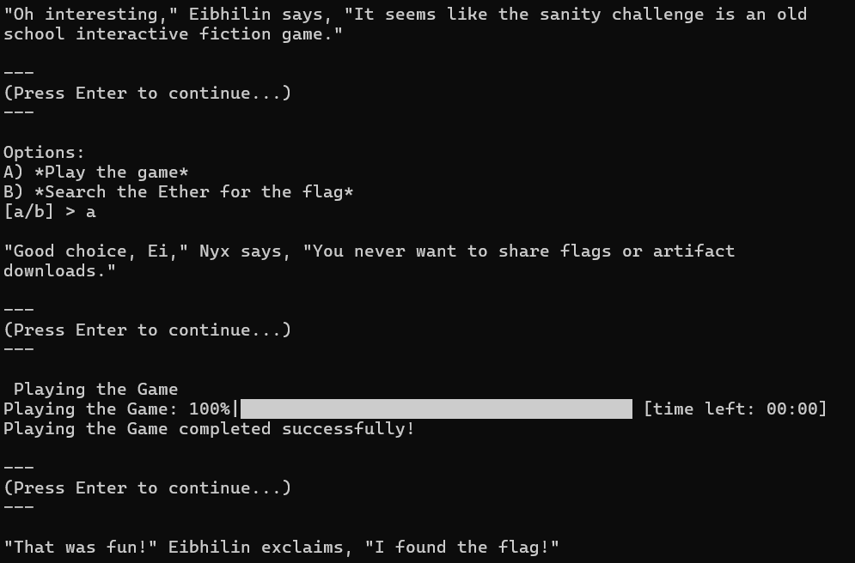
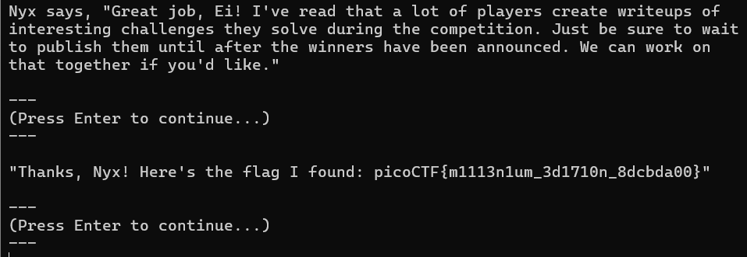
Flag: picoCTF{m1113n1um_3d1710n_8dcbda00

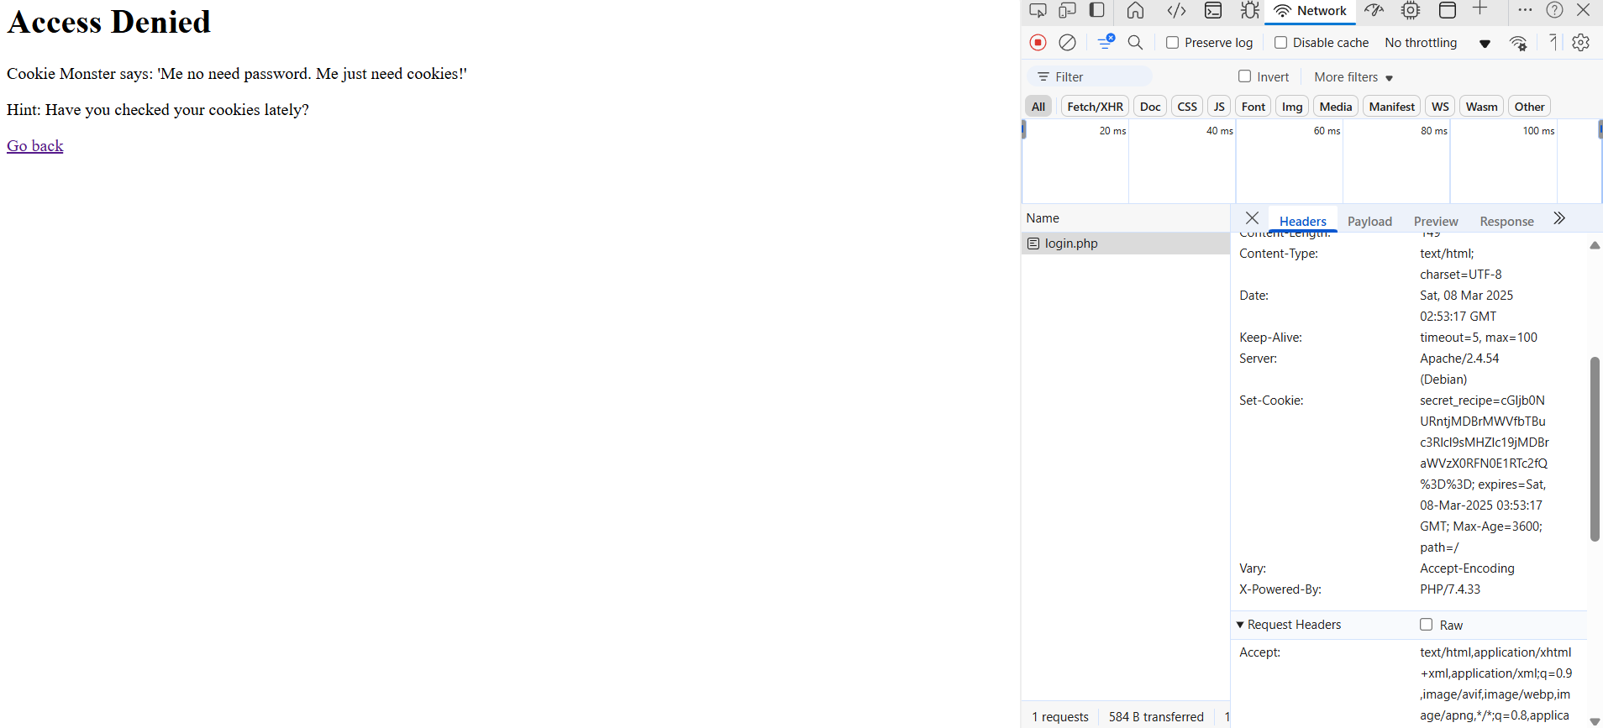
Inspect cookies to find flag.
Decode from Base 64 format to text.
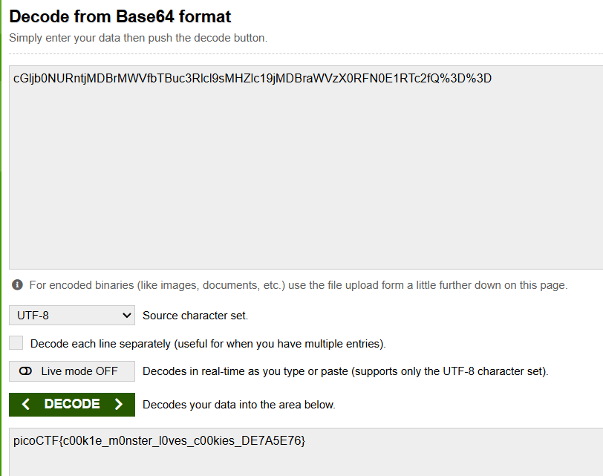
Flag: picoCTF{c00k1e_m0nster_l0ves_c00kies_DE7A5E76}

hashcrack
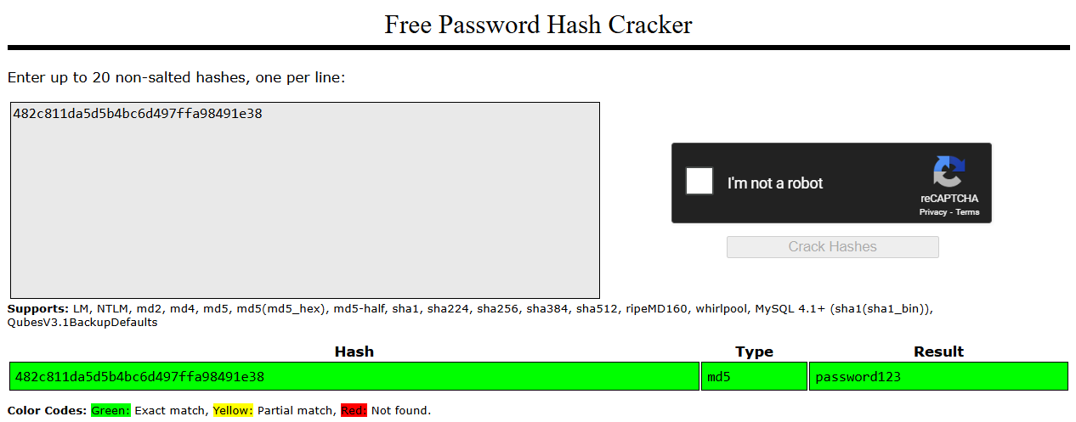
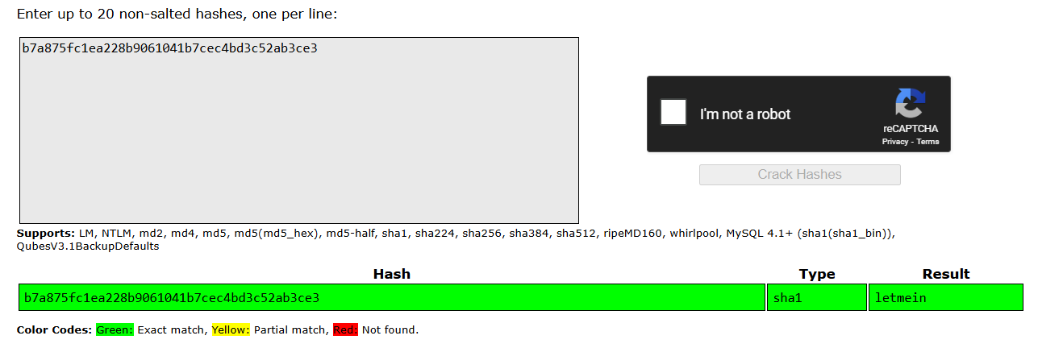
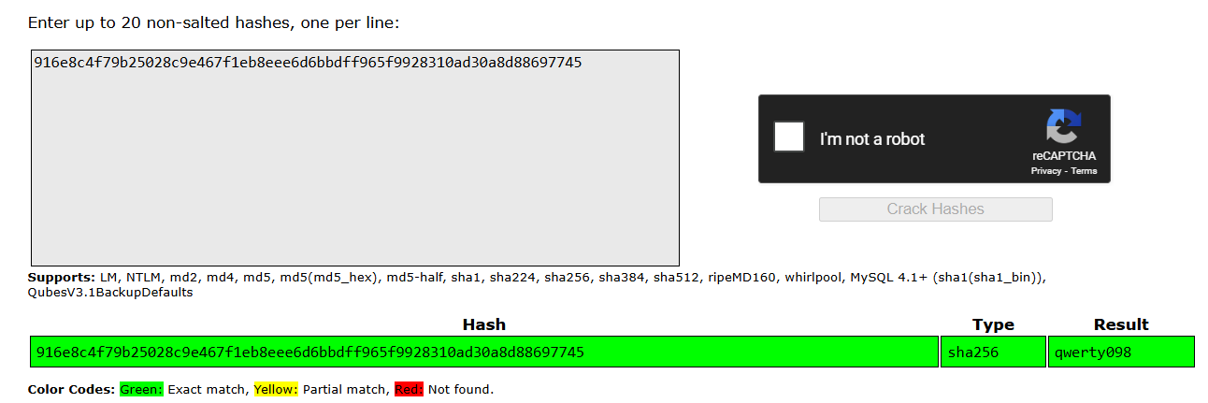
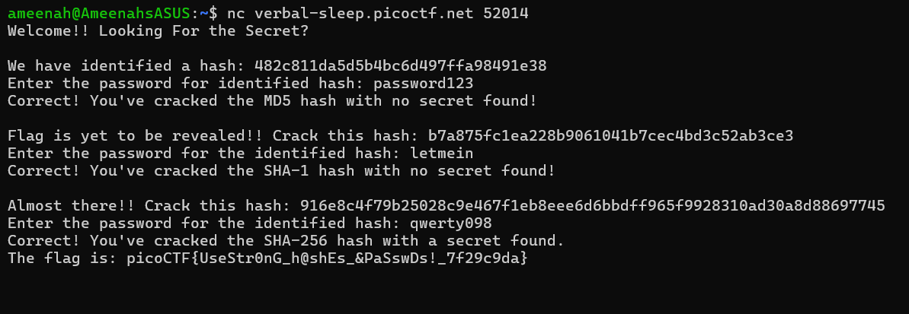
Unhash each hash string to find the password for each stage. The flag is then revealed.
Flag: picoCTF{UseStr0nG_h@shEs_&PaSswDs!_7f29c9da}

Phantom Intruder
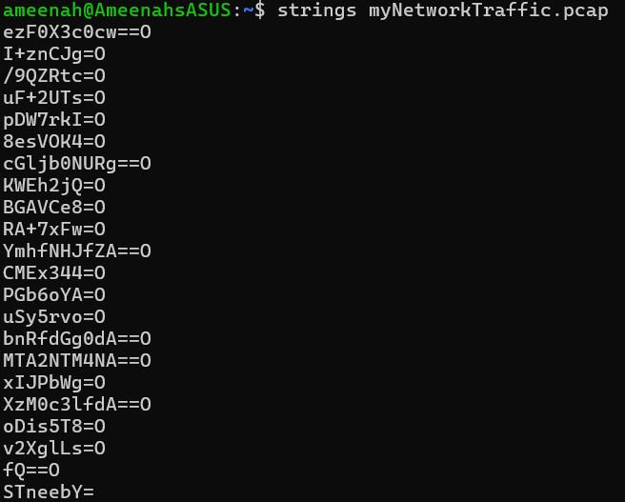
Strings of pcap file are analysed. The strings that end with two equal signs are decoded from base64 format. The resulting strings are rearranged to form the flag.
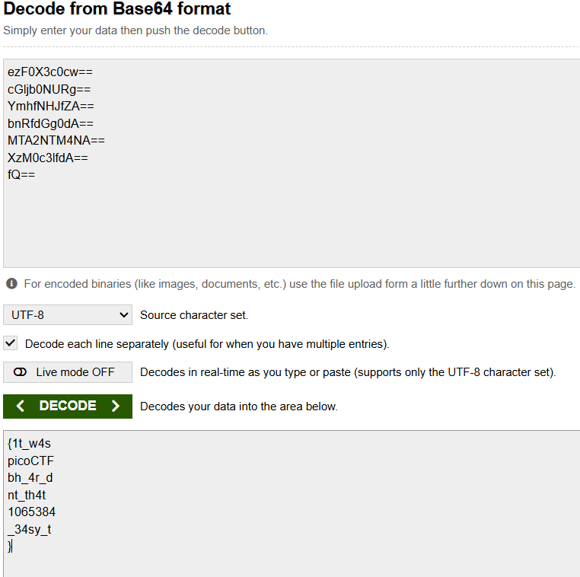
Flag: picoCTF{1t_w4snt_th4t_34sy_tbh_4r_d1065384}

flags are stepic (in progress)
I know the flag is hidden in the upz.png file. It is 1.7MB large while the other images are 600KB. And it’s not a country. But I can’t extract useful information. Strings, ls and binwalk are not giving me any results.
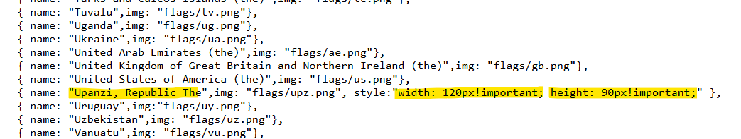

event viewing
Found first log that has installation information for Totally_Legit_Software. First third of flag was in base64 format.
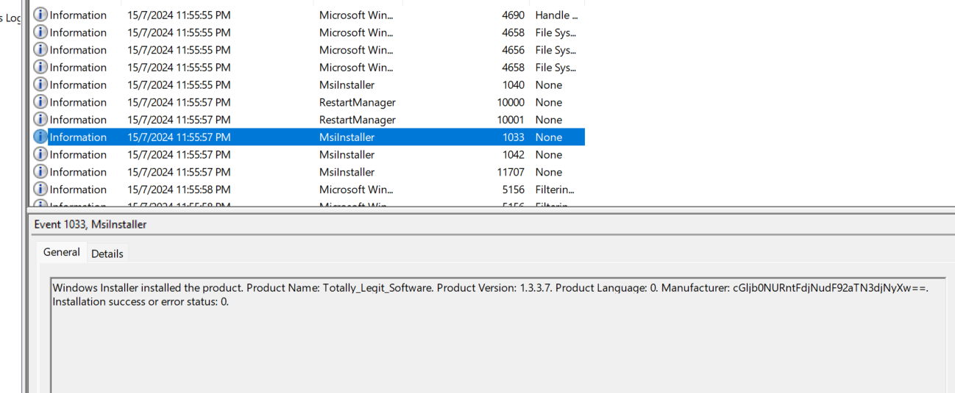
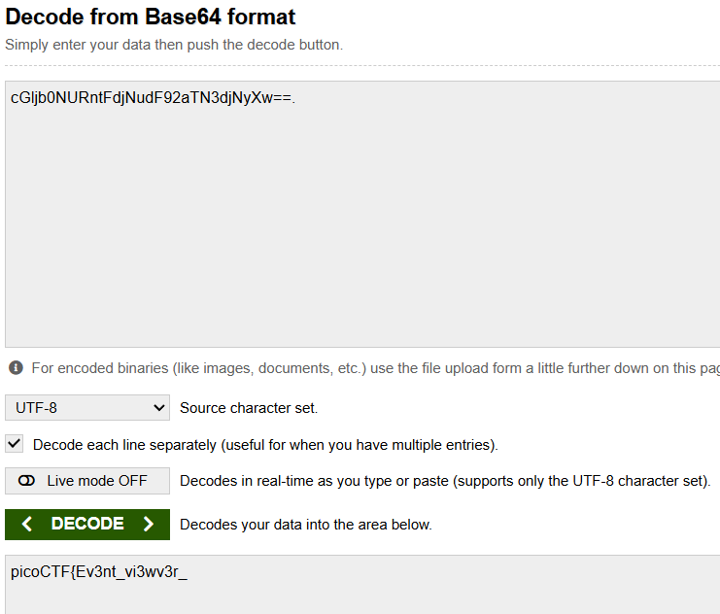
Scrolling through the following logs. I found another part of the flag in base64 format.
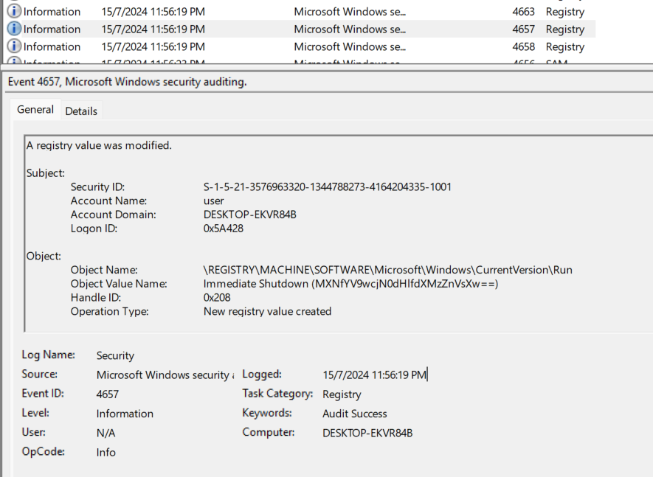
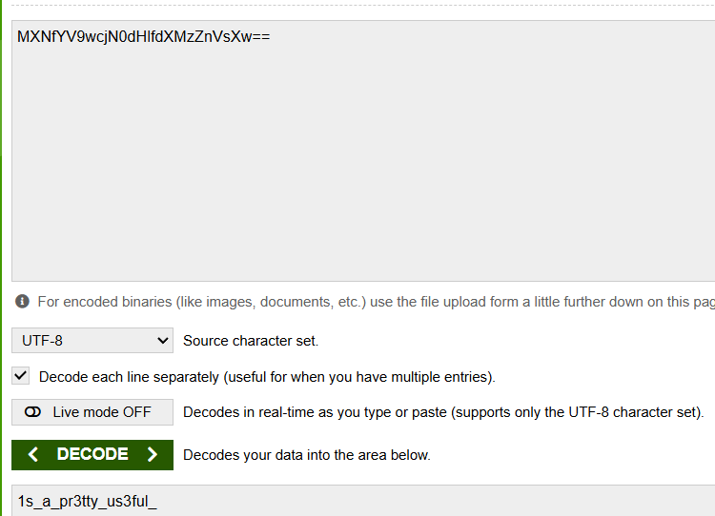
No luck running through times right after first shutdown. Scrolled to an hour later.
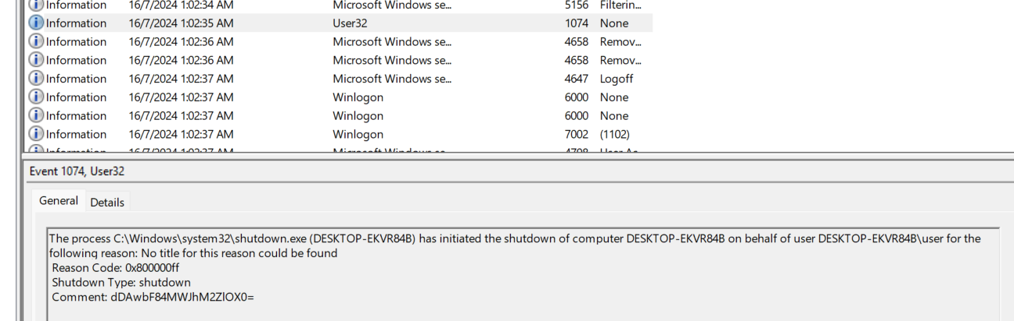
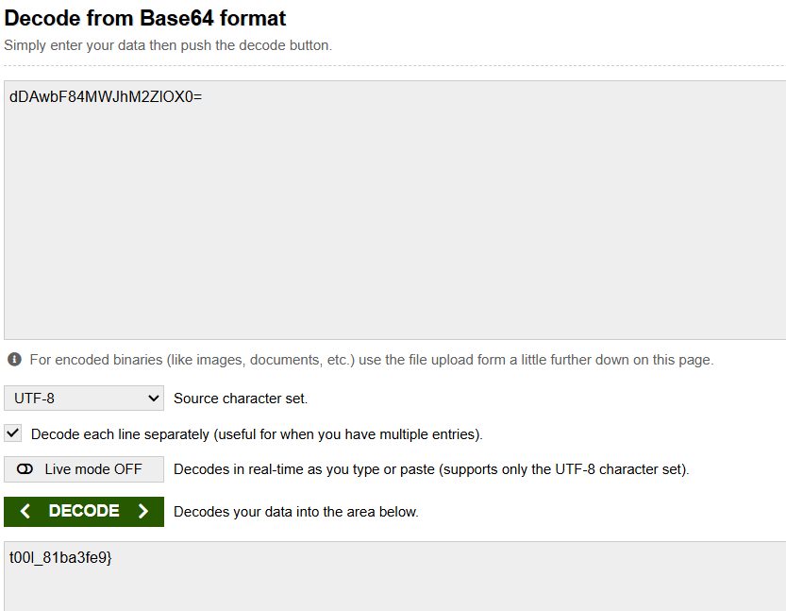
Flag: picoCTF{Ev3nt_vi3wv3r_1s_a_pr3tty_us3ful_t00l_81ba3fe9}

even rsa can be broken???
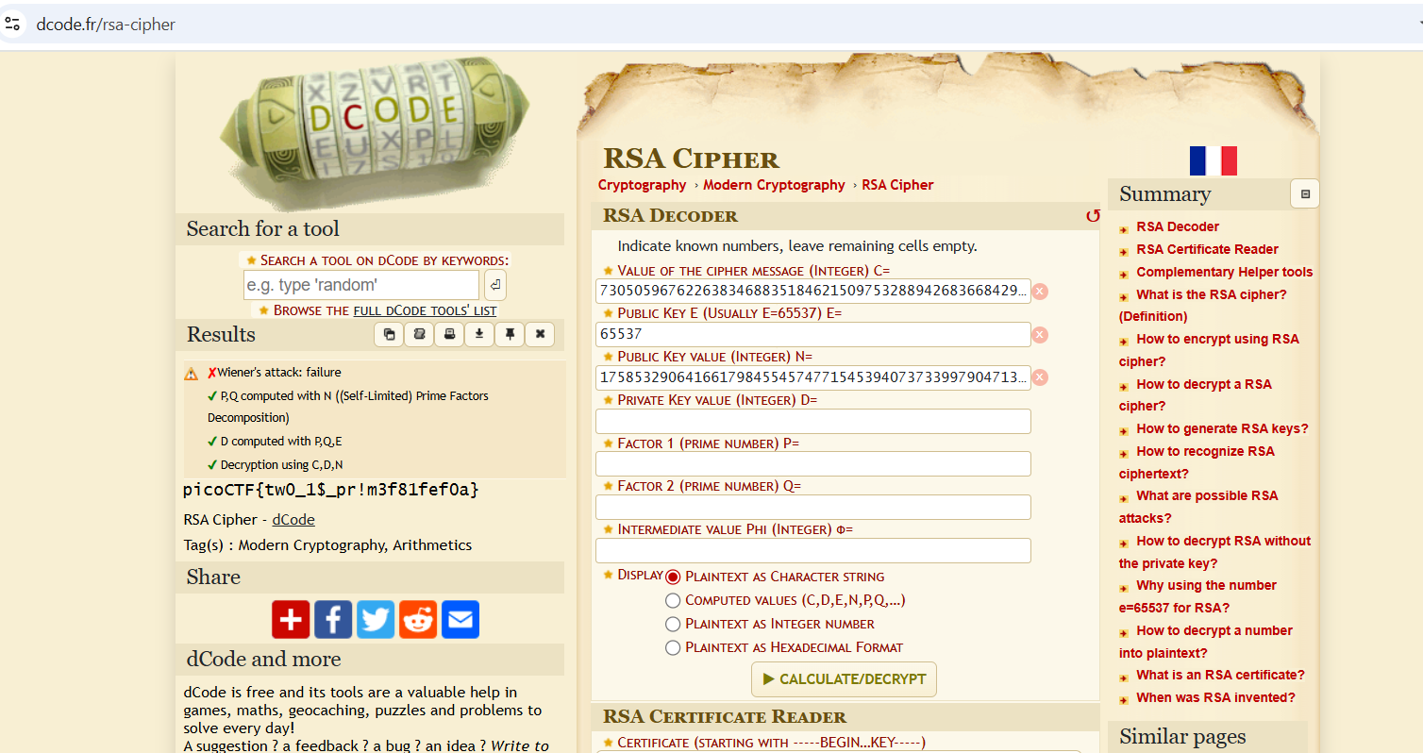
Insert e, N and ciphertext into website and decrypt to reveal flag.
Flag: picoCTF{tw0_1$_pr!m3f81fef0a}

head-dump

Click on the API documentation link. Once on the page, execute heapdump and download the file. Open it in notepad and search “pico”. This reveals the flag.
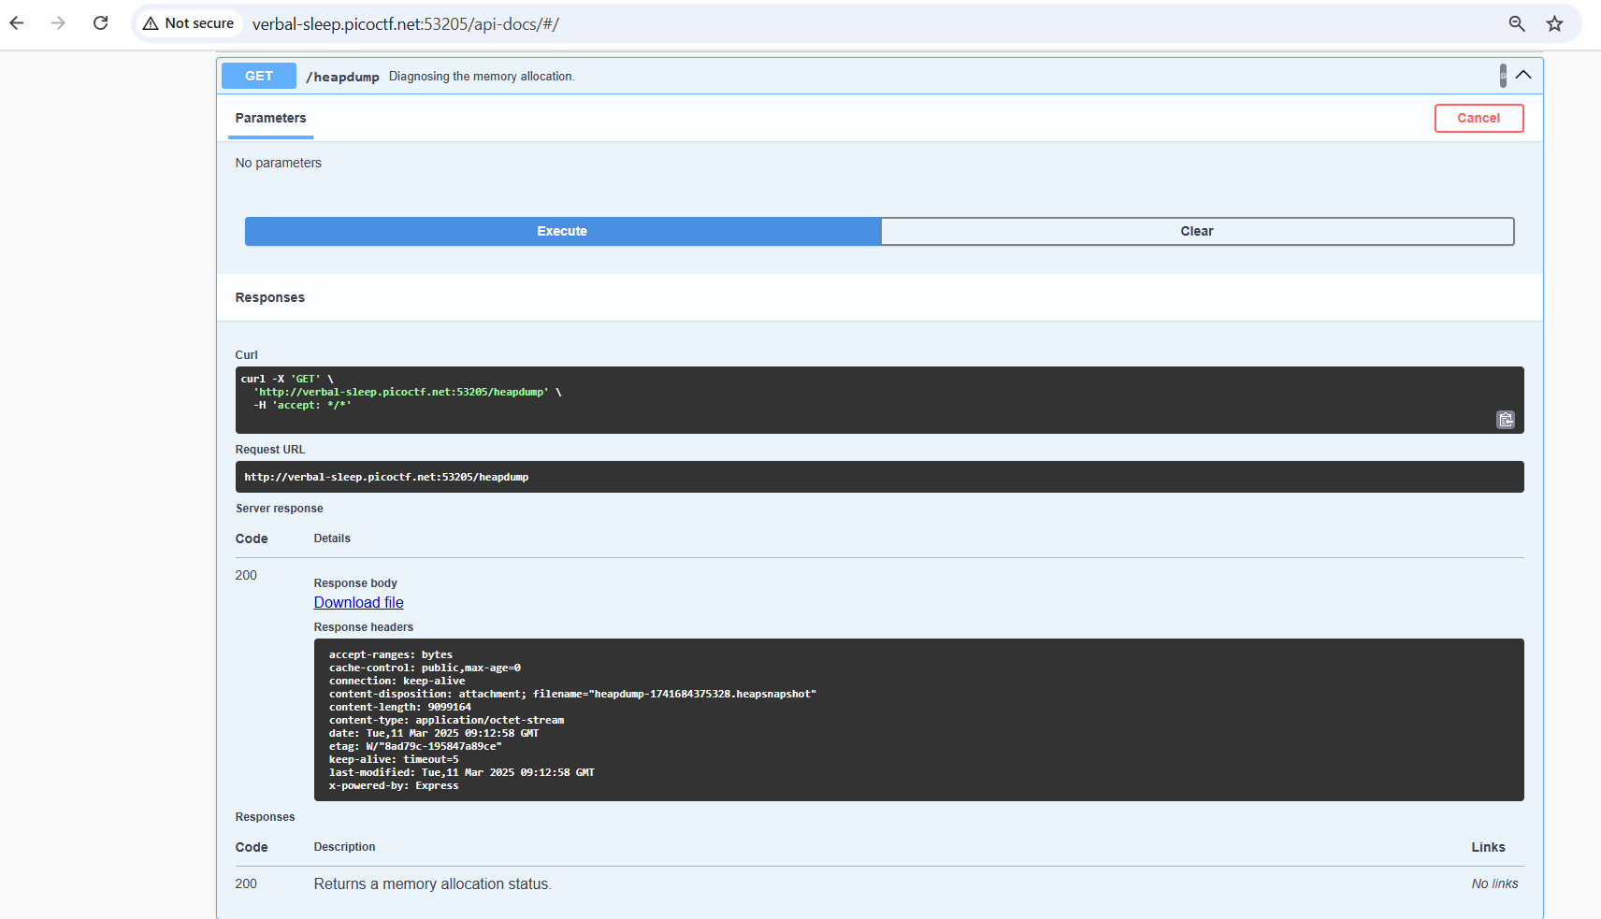
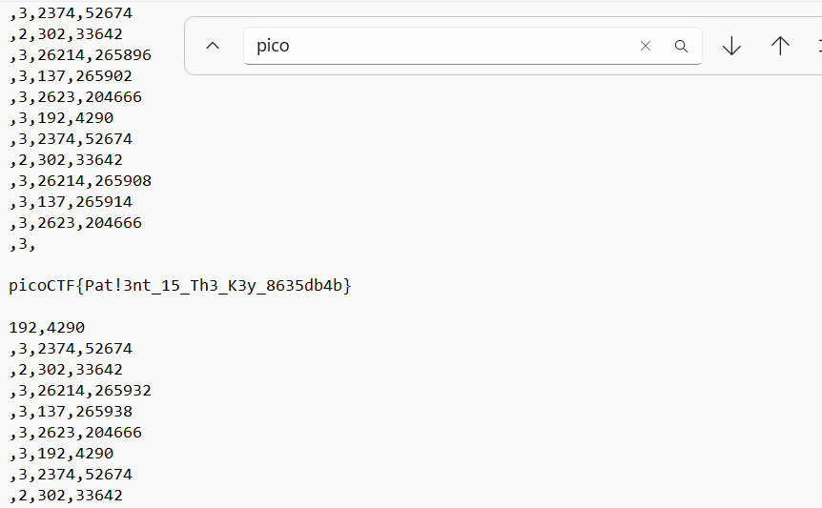
Flag: picoCTF{Pat!3nt_15_Th3_K3y_8635db4b}

quantum scrambler
After studying the pattern of quantum scrambling for a different numbers of letters, I noticed repetition begins after 4 letters. Repetition increases in powers of two for each increase in letter.
Mapped the word “pico” to its hexadecimal characters to start off. Then replaced remaining hexadecimal values. Sample shown below.
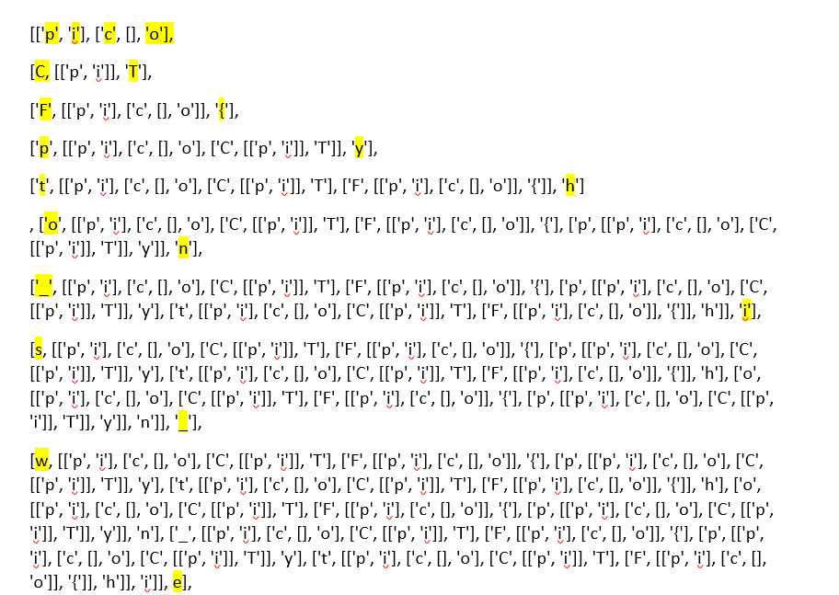
Flag: picoCTF{python_is_weirdd91a5340}

Pachinko
To understand the game, I looked at the code and did some research about Pachinko. In order to win the game, the inputs node values need to be flipped at the output. This needs to be achieved using the NAND gates which can be added by pressing the “Add intermediate Node” button. I needed to try several circuits until I got the flag.
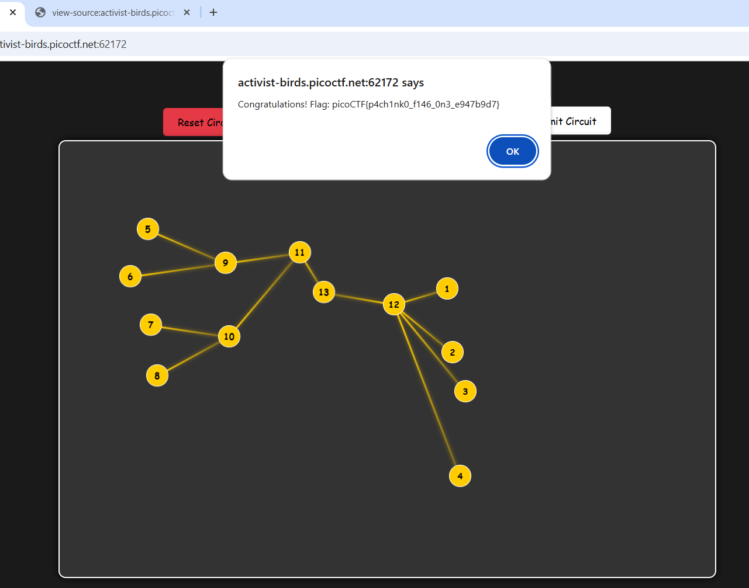
Flag: picoCTF{p4ch1nk0_f146_0n3_e947b9d7}

tap into hash
The steps used to encrypt the block chain are identified from the block_chain.py file. A random hex chain is first generated and converted to bytes. This is used as the key for the final encryption step. The block chain is then generated and a token is inserted into the middle. In this case the token is the picoCTF flag. Then it is padded to multiple blocks, each sized 16-bytes. Finally, each 16-byte block is XORed with the SHQ-256 hash of the key.
In order to decrypt the given block chain, the encryption steps need to be reversed. A python program is used to do that.
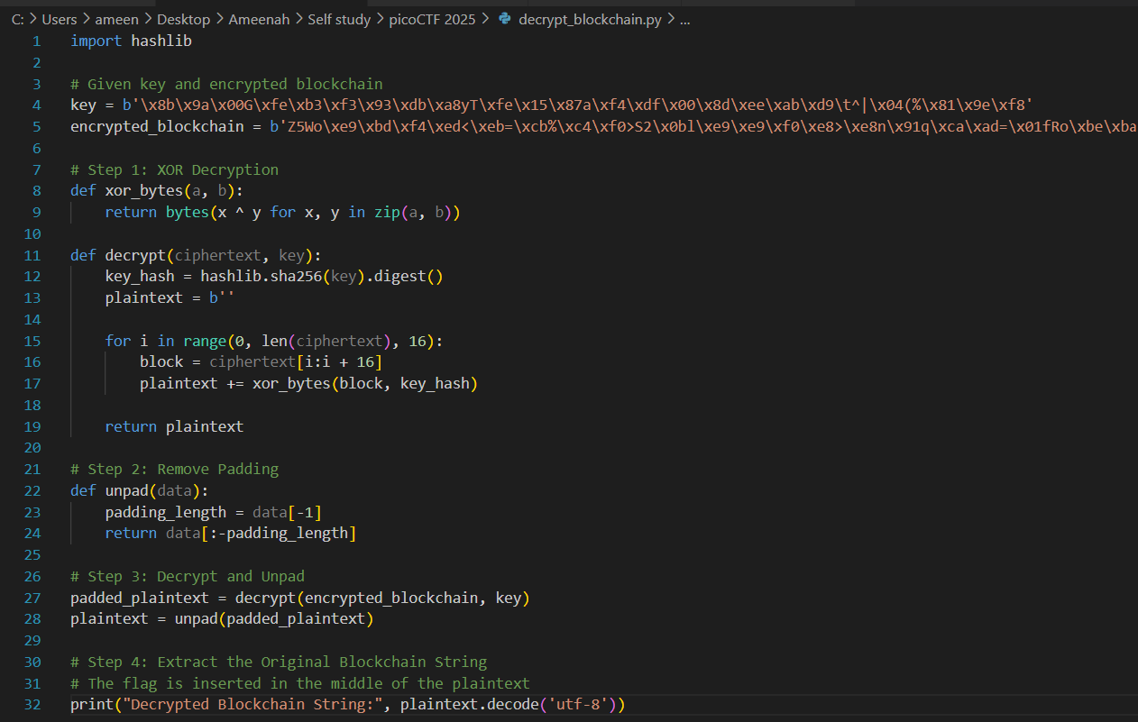
The flag is found in the middle of the decrypted block chain.
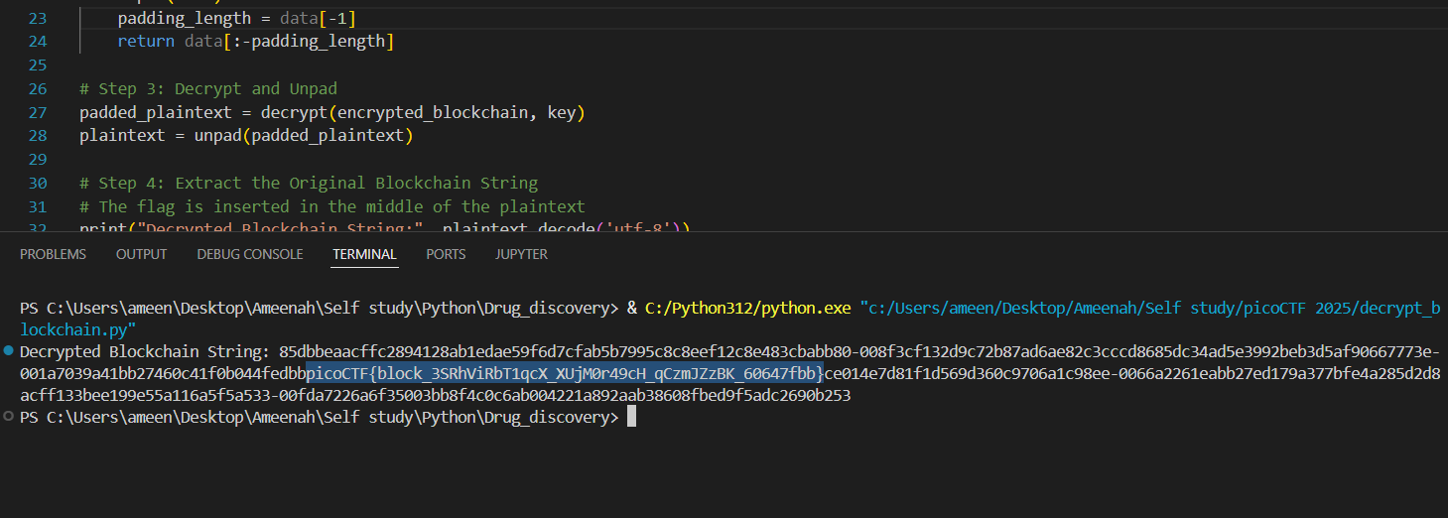
Flag: picoCTF{block_3SRhViRbT1qcX_XUjM0r49cH_qCzmJZzBK_60647fbb}

